American Indian programs and initiatives at Minnesota State

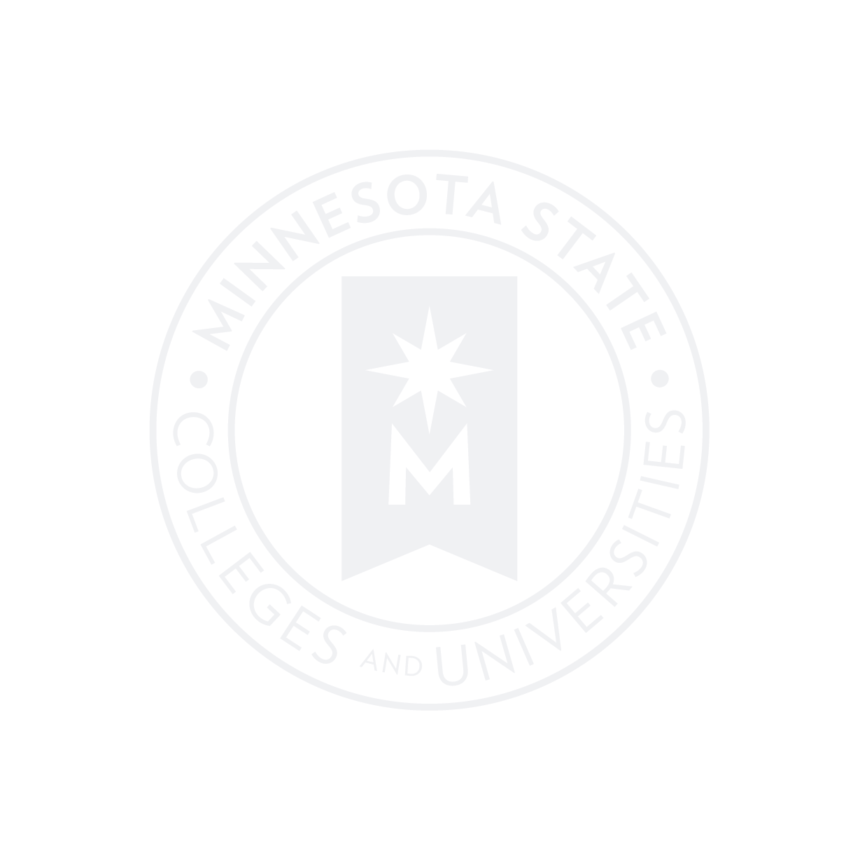**Serving American Indian Students and Communities**

The following information includes the Minnesota State institutions that offer degrees, diplomas, certificates, services, and programs aim to serve Native American students.

**-9 Institutions offer a concentration focused on Native History, culture, and/or legal systems.**

*These include Saint Cloud State University, Itasca Community College, Minnesota State University Mankato, Rainy River Community College, Minneapolis Community and Technical College, Lake Superior College, and Fond du Lac Tribal and Community College.*

**-5 Institutions offer a diploma focused on Native History, culture, and/or legal systems.**

*These include Saint Cloud State University, Itasca Community College, Rainy River Community College, Minneapolis Community and Technical College, and Fond du Lac Tribal and Community College.*

**-3 Institutions offer a Bachelor’s degree focused on Native History, culture, and/or legal systems.**

*These include Saint Cloud State University, Minnesota State University Mankato, and Bemidji State University.*

**-11 Institutions have staff explicitly assigned to serve American Indian students**

*These include Saint Cloud State University, Itasca Community College, Minnesota State University Mankato, Rainy River Community College, Minneapolis Community and Technical College, Lake Superior College, and Fond du Lac Tribal and Community College, Mesabi Range College, and Metro State University.*

**-5 Institutions have an American Indian Center on campus**

*These include Saint Cloud State University, Itasca Community College, Bemidji State University, Minneapolis Community and Technical College, and Fond du Lac Tribal and Community College*

**-13 Institutions offer programming specifically intended to serve American Indian students.**

These include *Saint Cloud State University, Itasca Community College, Minnesota State University Mankato, Rainy River Community College, Minneapolis Community and Technical College, Hennepin Technical College, Minnesota West Community and Technical College, North Hennepin Community College, Bemidji State University, Fond du Lac Tribal and Community College, Mesabi Range College, and Metro State University*

**-10 Institutions have an American Indian Advisory Council**

*These include Bemidji State University (shared with Northwest Technical College), Central Lakes College, Fond du Lac Tribal and Community College, Itasca Community College, Minneapolis Community and Technical College, Minnesota State University, Mankato, Minnesota State University Moorhead, Northwest Technical College (shared with Bemidji State University), Rainy River Community College, St Cloud State University*

**-15 institutions grant world language credit for demonstrated proficiency in an AI language**

*These include****:*** *Anoka Ramsey Community College****,*** *Central Lakes College****,*** *Fond du Lac Tribal and Community College****,*** *Lake Superior College, Minneapolis Community and Technical College****,*** *Northwest Technical College****,*** *Rainy River Community College****,*** *St. Cloud State University****,*** *Alexandria Technical and Community College****,*** *Bemidji State University, Dakota County Technical College****,*** *North Hennepin Community College, Pine Technical College****,*** *Ridgewater College****,*** *Winona State University*